

HVBS-912 /  HVBS-912G | Metal Working Bandsaw

50000435T…400/50/3

ITA912G……400/50/3

PARTS LIST
ERSATZTEILLISTE
LISTE DE PIECES


Walter Meier (TOOL) AG
Tämperlistr. 5
CH-8117 Fällanden
Switzerland
Phone +41 44 806 47 48
Fax +41 44 806 47 58
jetinfo.eu@waltermeier.com
www.jettools.com

P-50000435T / ITA912G 10/12

Breakdown for the HVBS-912 / HVBS-912G
Saw Base Assembly

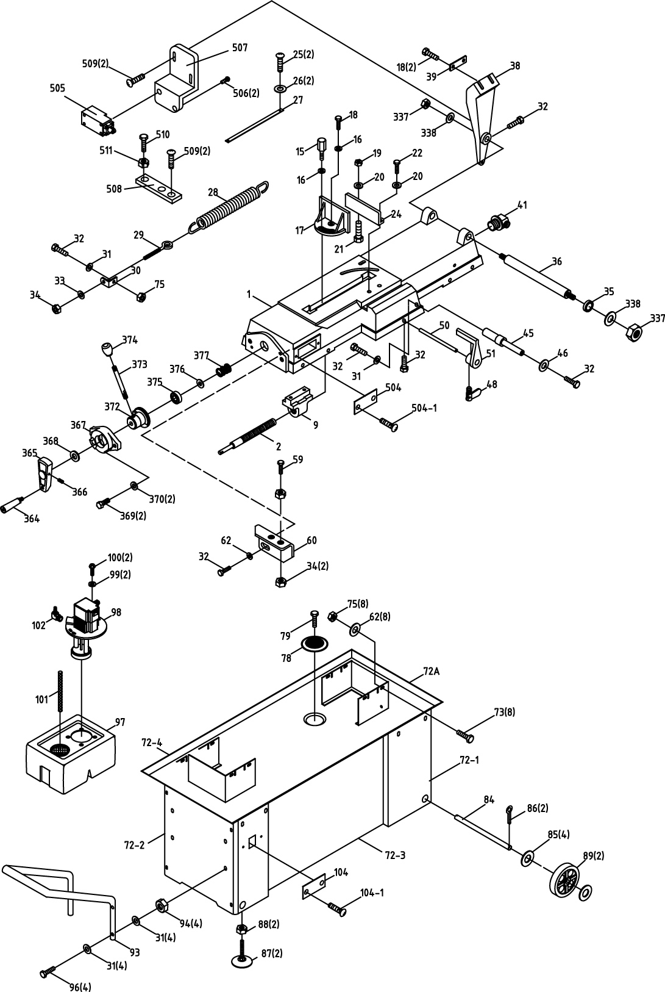

Parts List for the HVBS-912 / HVBS-912G
Saw Base Assembly

Index Part
No. No. Description Size Qty.

1 HVBS912-01 Swivel Base 1
2 HVBS912-02 Acme Lead Screw 1
9 HVBS912-09 Bracket 1
15 HVBS912-15 Fixed Bolt 1
16 TS-0680042 Flat Washer 3/8"x25xt2 2
17 HVBS-912-17 Vise Jaw Bracket (Front) 1
18 TS-0060071 Hex Cap Screw 3/8"x1-1/2"L 3
19 TS-0561052 Hex Nut 1/2" 1
20 TS-0680061 Flat Washer 1/2"x28xt2 2
21 HVBS912-21 Carriage Screw 1/2"x2"L 1
22 TS-0070051 Hex Cap Screw 1/2"x2"L 1
24 HVBS912-24 Vise Jaw Bracket (Rear) 1
25 HVBS912-25 Cross Round Head Screw 3/16"x3/8"L 2
26 TS-0680011 Flat Washer 3/16"x12xt0.8 2
27 HVBS912-27 Scale 1
28 HVBS912-28 Spring 1
29 HVBS912-29 Spring Adjusting Rod 1
30 HVBS912-30 Spring Handle Bracket 1
31 TS-0680031 Flat Washer 5/16"x23xt2 10
32 TS-0081031 Hex Cap Screw 5/16"x3/4"L 6
33 TS-0680041 Flat Washer 3/8"x23xt2 1
34 TS-0561031 Hex Nut 3/8" 3
35 HVBS912-35 Bushing 1
36 HVBS912-36 Support Rod 1
38 HVBS912-38 Pivot Bracket 1
39 HVBS912-39 Plate 1
41 HVBS912-41 Wire Nipple 5/8" 1
45 HVBS912-45 Cylinder Lower Support 1
46 HVBS912-46 Flat Washer 5/16"x19xt1.5 1
48 HVBS912-48 Thumb Screw 1
50 HVBS912-50 Stock Stop Rod 1
51 HVBS912-51 Stop Block 1
59 TS-0060081 Hex Cap Screw 3/8"x1-3/4"L 1
60 HVBS912-60 Support Plate 1
62 HVBS912-62 Flat Washer 5/16"x18xt1.5 9
72A HVBS912-72A Stand Complete Assembly (#72-1 thru 72-4) 1
72-1 HVBS912-72-1 Leg (Left) 1
72-2 HVBS912-72-2 Leg (Right) 1
72-3 HVBS912-72-3 Panel 1
72-4 HVBS912-72-4 Water Tray 1
73 TS-0051051 Hex Cap Screw 5/16"x1"L 8
75 TS-0561021 Hex Nut 5/16" 8
78 HBS912-78 Filter 1
79 TS-0050011 Hex Cap Screw 1/4"-20*1/2"L 1
84 HVBS912-84 Wheel Rod 1
85 HVBS912-85 Flat Washer 5/8"x30xt3mm 4
86 HVBS912-86 Cotter Pin ∮3x25L 2
87 HVBS912-87 Coaster of Stand 1/2" 2
88 HVBS912-88 Hex Nut 1/2"-12 2
89 HVBS912-89 Wheel 2

Index Part
No. No. Description Size Qty.

93 HVBS912-93 Hand Rod 1
94 TS-0561021 Hex Nut 5/16"-18 4
96 TS-0051071 Hex Cap Screw 5/16"-18x1-1/2"L 4
97 HVBS912-97 Coolant Tank 1
98 HVBS912-98AE Pump 400V, 50Hz, 3Ph 1
HVBS912-PLE Pump Label for CE (not shown) 1
99 TS-0680021 Flat Washer /4"x19xt1.5 2
100 HVBS912-100 Cross Round Head Screw /4"x5/8"L 2
101 HVBS912-101 Hose 5/8"x200mm 1
102 HVBS912-102 Coupler 3/8"PTx5/16" 1
104 HVBS912-104 Plate. 1
104-1 HVBS912-104-1 Cross Round Head Screw. 3/16” x 10 2
337 TS-0640112 Nut 1/2" 2
338 TS-0680061 Flat Washer 1/2"x28xt2 2
364 HVBS912-364 Knob 1
365 HVBS912-365 Knob 1
366 TS-0270051 Socket Set Screw 5/16"-18X1/2"L 1
367 HVBS912-367 Bracket 1
368 TS-2360121 Flat Washer M12xt2 1
369 TS-0060061 Hex Cap Screw 3/8"x1-1/4"L 2
370 TS-0680041 Flat Washer 3/8"x20xt2 2
372 HVBS912-372 Bracket 1
373 HVBS912-373 Shaft 1
374 HVBS912-374 Plastic Round Knob 1
375 HVBS912-375 Bearing 1
376 TS-2360121 Flat Washer M12 1
377 HVBS912-377 Spring 1
500 HVBS912-500 Power Cable 1
501 HVBS912-501 Pump-Cable 1
502 HVBS912-502 Limit-Cable 1
503 HVBS912-503 Motor-Cable 1
504 HVBS912-104 Plate. 1
504-1 HVBS912-104-1 Cross Round Head Screw. 3/16” x 10 2
505 HVBS912-505 Limit Switch 1
506 HVBS912-506 Pan Head Screw M4 x 25 2
507 HVBS912-507 Bracket 1
508 HVBS912-508 Stop Plate 1
509 HVBS912-509 Cross Round Head Screw 3/16” x 10 4
510 HVBS912-510 Hex Cap Screw 5/16” x 1-1/4” 1
511 HVBS912-511 Hex Nut 5/16” 1
** HVBS912-JL………………Jet Logo (not shown)………………………………………………………1
** HVBS912-IDE………….....ID Label for CE (not shown)…..………………………………………….1
** HVBS912-GL……………...Ground Label (not shown…………………………………………………1
** 601W-05L003……………..Warning Label for Saw (not shown)……………………………………..1
** 601W-05L005……………..Warning Label for Glasses (not shown)…………………………………1

Breakdown for the HVBS-912 / HVBS-912G
Saw Head Assembly

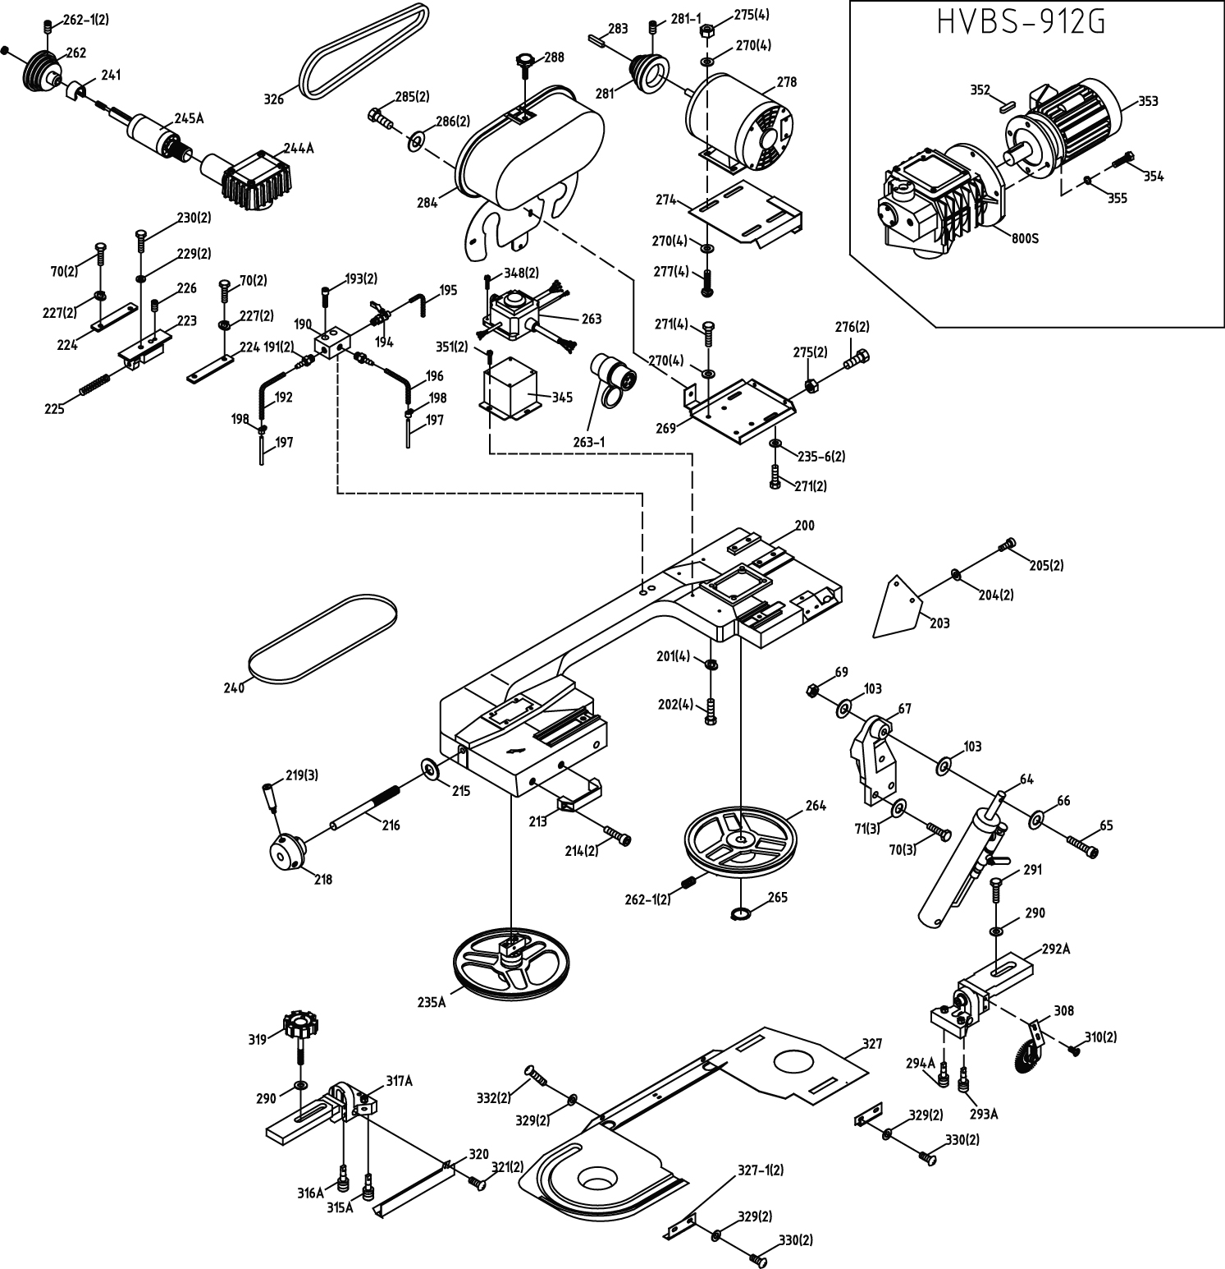

Breakdown for the HVBS-912 / HVBS-912G
Saw Bearing Bracket Assembly

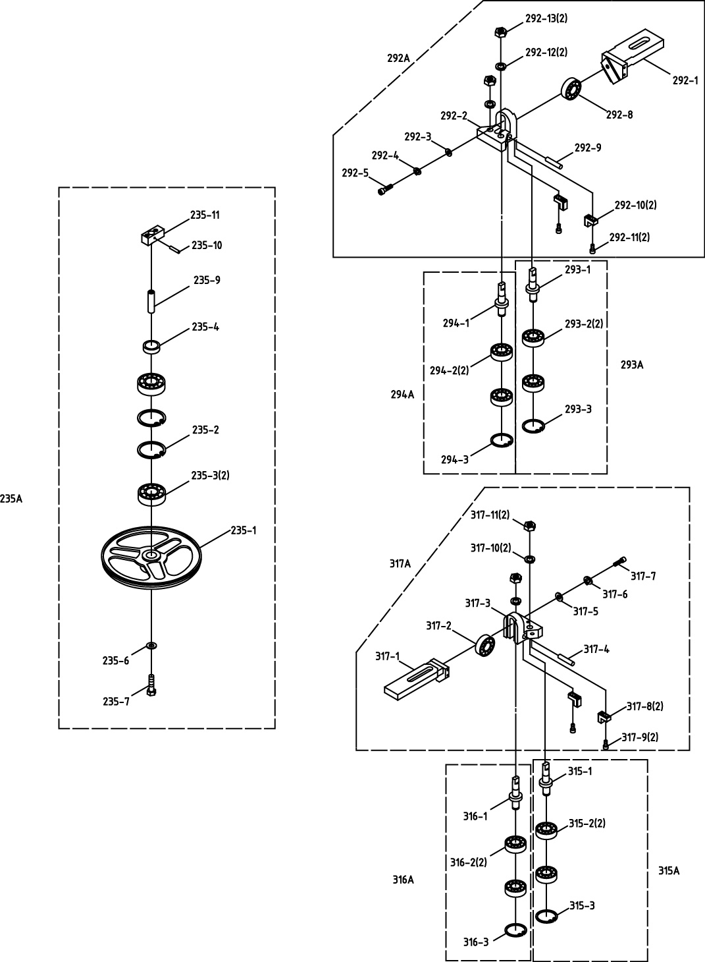

Breakdown for the HVBS-912
Saw Gear Assembly

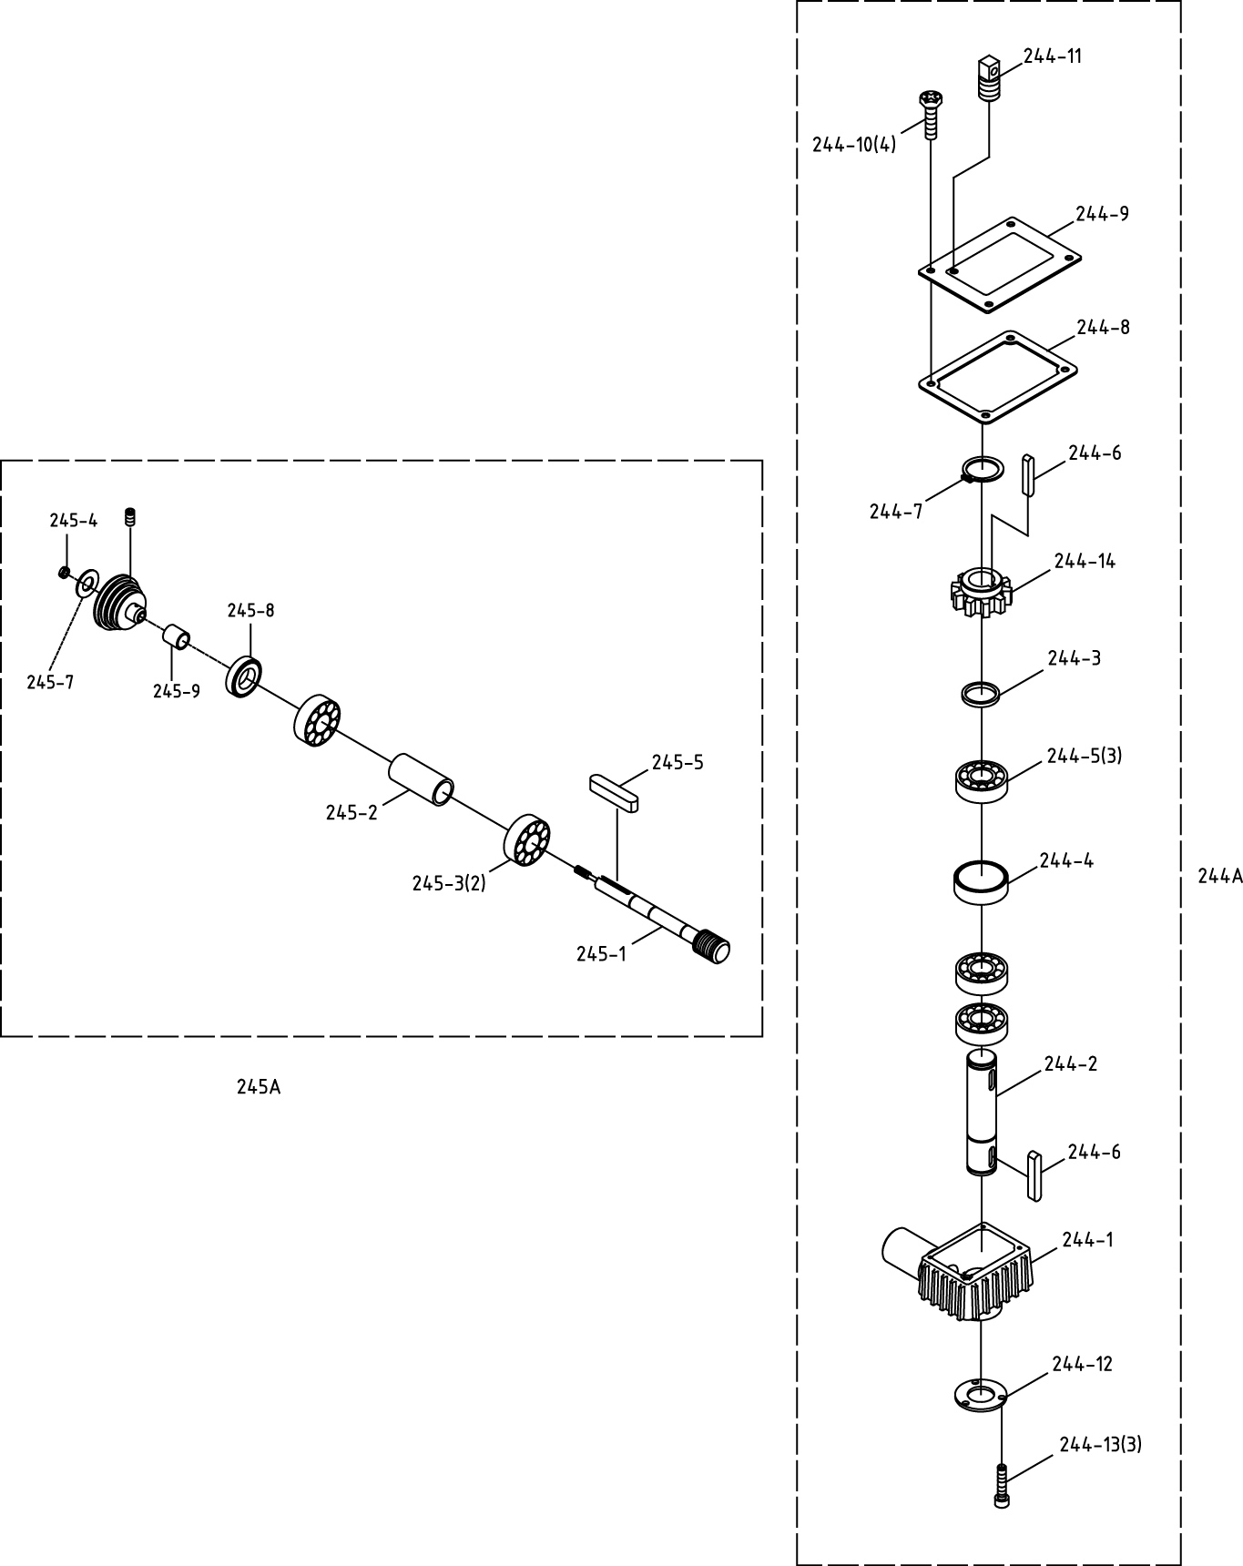

Parts List for the HVBS-912 / HVBS-912G
Saw Head Assembly

Index Part
No. No. Description Size Qty.

64 HVBS912-64 Cylinder Complete Set RF-712N 1
65 TS-0209102 Socket Head Cap Screw 3/8"x2-1/4"L 1
66 TS-0680041 Flat Washer 3/8"x25xt2 1
67 HVBS912-67 Pivot Arm 1
69 TS-0561031 Hex Nut 3/8" 1
70 TS-0051051 Hex Cap Screw 5/16"x1"L 7
71 TS-0680031 Flat Washer 5/16"x18xt1.5 3
103 HVBS912-103 Flat Washer 3/8"x20xt2 2
190 HVBS912-190 3 Way Valve 1
191 HVBS912-191 Tube Clamp 1/4PTx1/4" 2
192 HVBS912-192 Hose 8 x 6 x 1100(1/4") 1
193 TS-0207072 Socket Head Screw 1/4"x1-1/4"L 2
194 HVBS912-194 Valve 1/4"PTx5/16" 1
195 HVBS912-195 Hose 12 x 8 x 1400(5/16") 1
196 HVBS912-196 Hose 8 x 6 x 400(1/4") 1
197 HVBS912-197 Hose Bib 2
198 HVBS912-198 Hose Clamp 2
200 HVBS912-200 Bow ……………………………………………… 1
201 TS-0720091 Spring Washer 3/8" 4
202 TS-0060061 Hex Cap Screw 3/8"x1-1/4"L 4
203 HVBS912-203 Plate ……………………………………………… 1
204 TS-0680021 Flat Washer 1/4"x16xt1.5 2
205 HVBS912-205 Cross Socket Hex Cap Screw 1/4"x5/8"L 2
213 HVBS912-213 Knob 1
214 TS-0208061 Socket Head Cap Screw 5/16"x1"L 2
215 HVBS912-215 Flat Washer 3/8"x25xt2 1
216 HVBS912-216 Blade Tension Bar 1
218 HVBS912-218 Handle Body 1
219 HVBS912-219 Handle 3
223 HVBS912-223 Blade Tension Sliding Block 1
224 HVBS912-224 Sliding Plate 2
225 HVBS912-225 Spring 1
226 TS-0270071 Socket Set Screw 5/16"x3/4"L 1
227 TS-0720081 Spring Washer 5/16" 4
229 TS-0680031 Flat Washer 5/16"x12xt2 2
230 TS-0051071 Hex Cap Screw 5/16"x1-1/2"L 2
235A HVBS912-235A Idler Wheel Assembly (#235-1 ~ #235-11) 1
235-1 HVBS912-235-1 Idler Wheel 1
235-2 HVBS912-235-2 C-Retainer Ring R52 2
235-3 HVBS912-235-3 Bearing 6205LLU 2
235-4 HVBS912-235-4 Bushing 1
235-6 TS-0680031 Flat Washer 5/16"x20xt3 2
235-7 TS-0051081 Hex Cap Screw 5/16"x3/4"L 1
235-9 HVBS912-235-9 Blade Wheel Shaft 1
235-10 HVBS912-235-10 Pin ψ5x34L 1
235-11 HVBS912-235-11 Sliding Plate Draw Block 1
240 HVBS912-240 Blade (5-8T) 27x0.9x2655 1
241 HVBS912-241 Cover 1

Index Part
No. No. Description Size Qty.

244 HVBS912-244 Gear Box Assembly (Include #244A ~ 245A and 262, 262-1) 1
244A HVBS912-244A Gear Box Assembly (#244-1 ~ 244-14) 1
244-1 HVBS912-244-1 Gear Box 1
244-2 HVBS912-244-2 Transmission Shaft 1
244-3 HVBS912-244-3 Bushing 1
244-4 HVBS912-244-4 Bushing 1
244-5 HVBS912-244-5 Bearing 6205LLU 3
244-6 HVBS912-244-6 Key 6x6x20L 2
244-7 HVBS912-244-7 C-Retainer Ring S25 1
244-8 HVBS912-244-8 Gear Box Gasket 1
244-9 HVBS912-244-9 Gear Box Cover 1
244-10 HVBS912-244-10 Cross Socket Hex Head Screw 1/4"x5/8"L 4
244-11 HVBS912-244-11 Vent Plug M8xP1 1
244-12 HVBS912-244-12 Bearing Cover 1
244-13 HVBS912-244-13 Cross Round Head Screw 3/16"x3/8"L 3
244-14 HVBS912-244-14 Worm Gear 1
245A HVBS912-245A Worm Gear Shaft Assembly (#245-1 ~ 245-9) 1
245-1 HVBS912-245-1 Worm Shaft 1
245-2 HVBS912-245-2 Bearing Bushing 1
245-3 HVBS912-245-3 Bearing 6003LLU 2
245-4 HVBS912-245-4.................Lock Nut…… 1/2"-12………………..1
245-5 HVBS912-245-5 Key 5x5x30L 1
245-7 HVBS912-245-7 Flat Washer 1/2” 1
245-8 HVBS912-245-8 Special Nut M42xP2 1
245-9 HVBS912-245-9 Bushing 1
262 HVBS912-262 Spindle Pulley 1
262-1 TS-0267042 Socket Set Screw 1/4"x3/8"L 4
263 HVBS912-263AE Switchbox complete with cables 400V,50Hz,3Ph 1
263-1 HVBS912-263-1 Plug… 400V, 5Pin 1
264 HVBS912-264 Drive Wheel 1
265 HVBS912-265 C-Retainer Ring S25 1
269 HVBS912-269 Motor Mount Bracket 1
270 TS-0680031 Flat Washer 5/16"x23xt2 12
271 TS-0081031 Hex Cap Screw 5/16"x3/4"L 6
274 HVBS912-274 Motor Mount Plate 1
275 TS-0561021 Hex Nut 5/16" 6
276 TS-0081051 Hex Cap Screw 5/16"x1"L 2
277 TS-0152011 Carriage Screw 5/16"x1"L 4
278 HVBS912-278AE Motor 1HP, 400V,50Hz,3ph 1
281 HVBS912-281 Motor Pulley 1
281-1 TS-0267041 Socket Set Screw 1/4"x3/8"L 1
283 HVBS912-283 Key…………………………………………………5x5x30L 2
284 HVBS912-284 Motor Pulley Cover 1
HVBS56M-CLB/CE Caution Label for Pulley Cover (not shown) 1
285 TS-0050011 Hex Cap Screw 1/4" x 1/2"L 2
286 TS-0720071 Spring Washer 1/4" 2
288 HVBS912-288 Knob. 1
290 TS-0680041 Flat Washer 3/8"x25xt2 2
291 TS-0060061 Hex Cap Screw 3/8"x1-1/4"L 1

Index Part
No. No. Description Size Qty.

292A HVBS912-292A Adjustable Bracket Assembly (Rear) (#292-1 ~ #292-13) 1
292-1 HVBS912-292-1 Adjustable Bracket 1
292-2 HVBS912-292-2 Blade Adjustable 1
292-3 TS-0680031 Flat Washer 5/16"x18xt1.5 1
292-4 TS-0720081 Spring Washer 5/16" 1
292-5 TS-0208071 Socket Head Cap Screw 5/16"x1-1/4"L 1
292-8 HVBS912-292-8 Bearing 608ZZ 1
292-9 HVBS912-292-9 Bearing Pin 2
292-10 HVBS912-292-10 Carbide Guide 2
292-11 TS-1503041 Socket Head Cap Screw M6x16L 2
292-12 TS-0720091 Spring Washer 3/8" 2
292-13 TS-0561031 Hex Nut 3/8"UNF 2
293A HBS912-293A Guide Pivot (Rear) (#293-1 ~ #293-3) 1
293-1 HVBS912-293-1 Guide Pivot (Rear) 1
293-2 HVBS912-293-2 Bearing 608ZZ 2
293-3 HVBS912-293-3 C-Retainer Ring S8 1
294A HVBS912-294A Bearing Shaft (#294-1 ~ #294-3) 1
294-1 HVBS912-294-1 Bearing Shaft 1
294-2 HVBS912-294-2 Bearing 608ZZ 2
294-3 HVBS912-294-3 C-Retainer Ring S8 1
308 HVBS912-308 Brush Assembly 1
310 HVBS912-310 Cross Round Head Screw 3/16"x3/8"L 2
315A HVBS912-315A Guide Pivot (Front) (#315-1 ~ #315-3) 1
315-1 HVBS912-315-1 Guide Pivot (Front) 1
315-2 HVBS912-315-2 Bearing 608ZZ 2
315-3 HVBS912-315-3 C-Retainer Ring S8 1
316A HVBS912-316A Bearing Shaft (#316-1 ~ #316-3) 1
316-1 HVBS912-316-1 Bearing Shaft 1
316-2 HVBS912-316-2 Bearing 608ZZ 2
316-3 HVBS912-316-3 C-Retainer Ring S8 1
317A HVBS912-317A Adjustable Bracket Assembly (Front) ((#317-1 ~ #317-11) 1
317-1 HVBS912-317-1 Adjustable Bracket (Front) 1
317-2 HVBS912-317-2 Bearing 608ZZ 1
317-3 HVBS912-317-3 Blade Adjustable (Rear) 1
317-4 HVBS912-317-4 Bearing Pin 1
317-5 HVBS912-317-5 Flat Washer 5/16"x18xt1.5 1
317-6 HVBS912-317-6 Spring Washer 5/16" 1
317-7 HVBS912-317-7 Socket Head Cap Screw 5/16"x1-1/4"L 1
317-8 HVBS912-317-8 Carbide Guide 2
317-9 HVBS912-317-9 Socket Head Cap Screw M6x16L 2
317-10 HVBS912-317-10 Spring Washer 3/8" 2
317-11 HVBS912-317-11 Hex Nut 3/8"UNF 2
318 HVBS912-318 Flat Washer 3/8"x25xt2 1
319 HVBS912-319 Knob ……………………………………………… 1
320 HVBS912-320 Blade Guard 1
321 HVBS912-321 Cross Round Head Screw 5/32"x1/4"L 2
326 HVBS912-326 Belt 3V-270 1
327 HVBS912-327 Blade Cover 1
HVBS56M-CLB/CE Caution Label for Blade Back Cover (not shown) 1
327-1 HVBS912-327-1 Plate. 1

Index Part
No. No. Description Size Qty.

329 TS-0680021 Flat Washer 1/4"x16xt1.5 6
330 HBS912-330 Cross Round Head Screw 1/4"x1/2"L 4
332 HVBS912-332 Cross Round Head Screw 1/4" x 1/2" 2
340 HVBS912-340 Bracket for CE Only 1
341 HVBS912-341 Cross Round Head Screw M4x5L 2
342 HVBS912-342 Switch Base 1
343 TS-1550031 Flat Washer M5 2
344 HVBS912-344 Cross Round Head Screw M5x10L 2
345 HVBS912-345 Control Box Base 1
348 HVBS912-348 Cross Round Head Screw M6x12L 4
351 TS-1503021 Socket Head Cap Screw M6-1.0Px10L 2
352 HBS814GH-801 Key……. .. 6 x 6 x 40L 1
353 HVBS912G-353AE Motor 1HP, 400V,50Hz,3ph 1
354 TS-1505041 Socket Head Cap Screw M10-1.5 x 30L 4
355 TS-2361101 Lock Washer M10 4

Breakdown for the HVBS-912G
Saw Gear Assembly

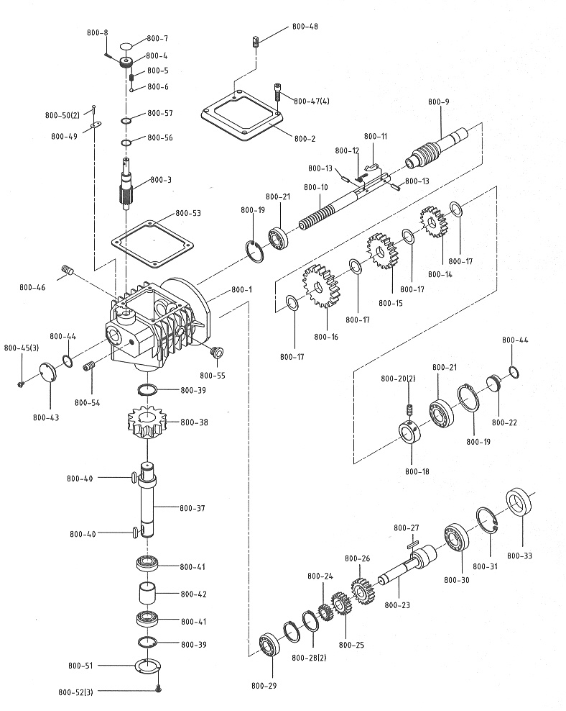

HVBS-912G Parts List: Gear Box Assembly
Index No. Part No. Description Size Qty
HBS814GH-800 The whole of Gear Box Assembly 1
800-1 HBS814GH-800-1 Gear Box Enclosure 1
800-2 HBS814GH-800-2 Gear Box Cover 1
800-3 HBS814GH-800-3 Speed-Changing Gear Shaft 1
800-4 HBS814GH-800-4 Speed Lever 1
800-5 HBS814GH-800-5 Spring 1
800-6 SB-8MM Steel Ball 8 1
800-7 HBS814GH-800-7 Speed Indicator Dial 1
800-8 TS-1502071 Socket Head Cap Screw M5-0.8 x 28L 1
800-9 HBS814GH-800-9 Worm Shaft 1
800-10 HBS814GH-800-10 Speed-Changing Rod 1
800-11 HBS814GH-800-11 Speed-Changing Key 1
800-12 HBS814GH-800-12 Torsion Spring 1
800-13 HBS814GH-800-13 Pin 3 x 10L 2
800-14 HBS814GH-800-14 Gear 1
800-15 HBS814GH-800-15 Gear 1
800-16 HBS814GH-800-16 Gear 1
800-17 HBS814GH-800-17 Washer 4
800-18 HBS814GH-800-18 Bushing Bracket 1
800-19 PWBS14-123 C-Retainer Ring R35 2
800-20 TS-1523011 Socket Set Screw M6-1 x 6L 2
800-21 HBS814GH-800-29 Bearing 6003LLB 2
800-22 HBS814GH-800-22 Cover 1
800-23 HBS814GH-800-23 Gear Shaft 1
800-24 HBS814GH-800-24 Gear 1
800-25 HBS814GH-800-25 Gear 1
800-26 HBS814GH-800-26 Gear 1
800-27 6291479 Key 5 x 5 x 32L 1
800-28 5513018 C-Retainer Ring S17 2
800-29 HBS814GH-800-29 Bearing 6003LLB 1
800-30 HBS814GH-800-30 Bearing 6007LLB 1
800-31 HBS814GH-800-31 C-Retainer Ring R62 1
800-33 HBS814GH-800-33 Oil Seal 62 x 35 x 8 1
800-37 HBS814GH-800-37 Drive Gear Shaft 1
800-38 HBS814GH-800-38 Worm Gear 1
800-39 5519933 C-Retainer Ring S25 2
800-40 1020A-292 Key 6 x 6 x 20L 2
800-41 HBS814GH-800-41 Bearing 60205LLB 2
800-42 HBS814GH-800-42 Bearing Spacer 1
800-43 HBS814GH-800-43 Cover 1
800-44 HBS814GH-800-44 O-Ring 35 x 29 x 3 2
800-45 TS-1533042 Cross Round Head Screw M5-0.8 x 13L 3
800-46 HBS814GH-800-46 Plug PT3/8" 1
800-47 TS-1503051 Socket Head Cap Screw M6-1 x 20L 4
800-48 HBS814GH-800-48 Vent Plug 1
800-49 HBS814GH-800-49 Scale 1
800-50 HBS814GH-800-50 Rivet 2 x 4 2
800-51 HBS814GH-800-51 Bearing Cover 1
800-52 TS-1533032 Cross Round Head Screw M5-0.8 x 10L 3
800-53 HBS814GH-800-53 Gear Box Gasket 1
800-54 HBS814GH-800-54 Plug PT1/4" 1
800-55 HBS814GH-800-55 Oil level gauge 19 1
800-56 HBS814GH-800-56 O- Ring 15.8 x 2.4b 1
800-57 HBS814GH-800-57 C-Retainer Ring R20 1
HVBS-912 / HVBS-912G 400/50/3
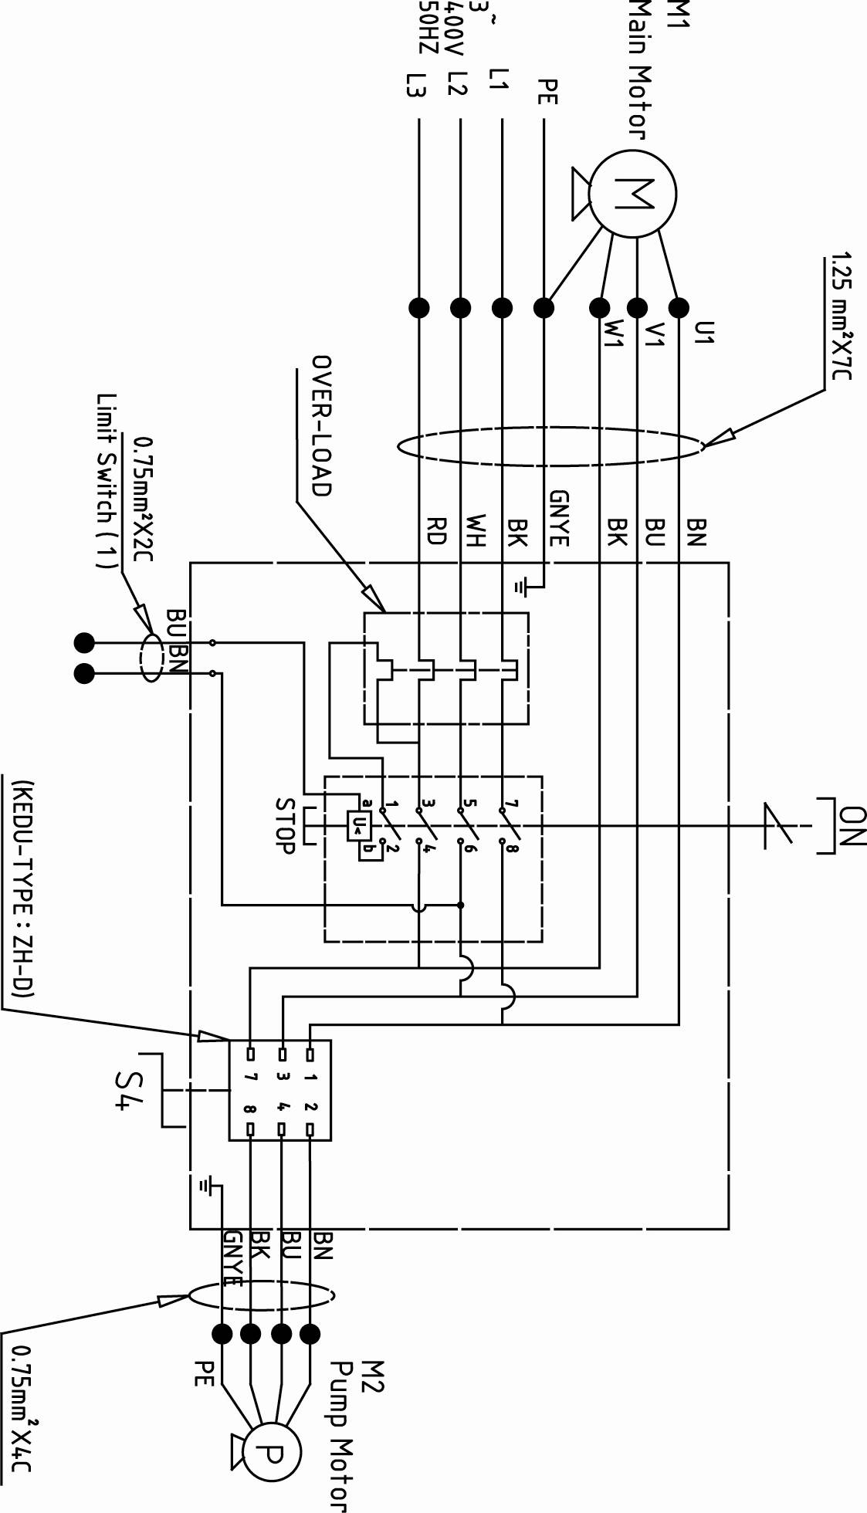
50000435T / ITA912G

 | colour of strands | Litzenfarben | couleur des cordons
BK | black | schwarz | noir
WH | white | weiß | blanc
BU | blue | blau | bleu
RD | red | rot | rouge
BN | brown | braun | brun
GNYE | green-yellow | grün-gelb | vert-jaune

 | meaning of symbol | Bedeutung der Zeichen | interprétation
M1 | Main motor | Hauptmotor | Moteur principal
M2 | Pump motor | Kühlmittelmotor | Moteur pompe
S4 | Pump motor switch | Kühlmittel-Schalter | Boution pompe

